**Output Screenshots:**

**Opening page:**

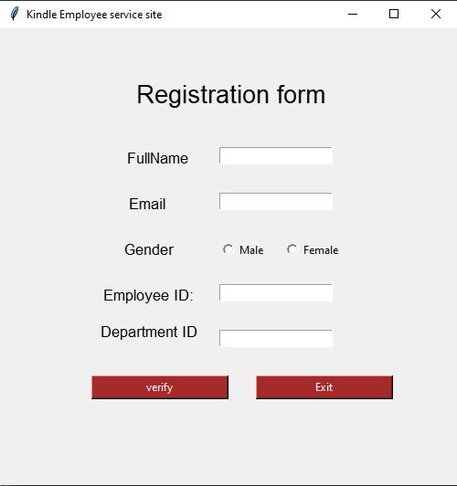

**After Entering data in the form:**

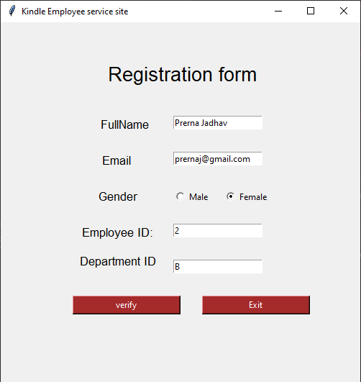

**When Clicked on Exit, the forms gets closed (exits)**

**When clicked verify the below given page gets displayed.**

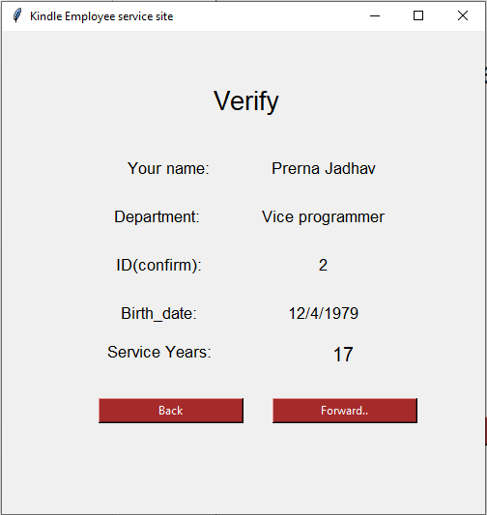

**After clicking back, one gets to go to the previous page.**

**On clicking Forward the below given output appears.**

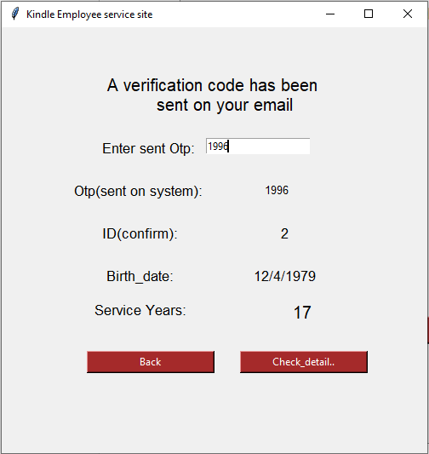

**After clicking back, one gets to go to the previous page.**

**On clicking check_details the below given output appears.**

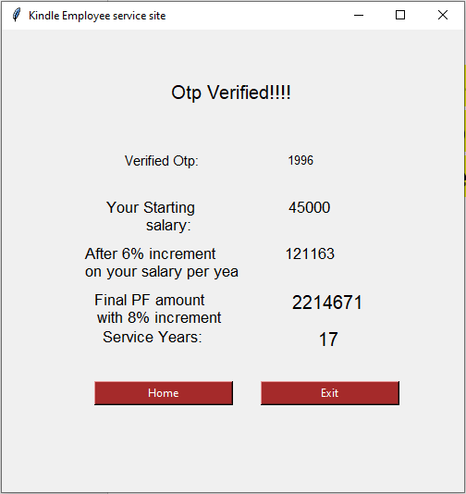

**On clicking home on gets back to the homepage and on clicking Exit one terminates the form.**